Name: _______________________________________________ Date: _________________________ Block: ________

Endosymbiosis Theory: Part II
A Theory on the Origins of Eukaryotic Cells: Mitochondria and Chloroplasts

Endosymbiosis is a type of symbiosis in which one organism lives inside the other, the two typically behaving as a single organism. The image below summarizes this concept.

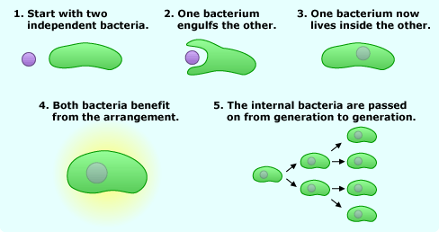

Simply stated, the theory of endosymbiosis is the concept that mitochondria and chloroplasts are the result of years of evolution initiated by the endocytosis of bacteria and blue-green algae which, instead of becoming digested, became symbiotic or helpful to the host cell.
Chloroplasts probably evolved in a manner similar to that of mitochondria. However, chloroplasts probably were ingested by only some eukaryotic cells, and were ingested after the first mitochondrion. This is why almost all eukaryotes have mitochondria but only some have chloroplasts. Certain eukaryotic cells ingested smaller prokaryotic autotrophic cells (cells that were able to convert the energy of sunlight into a food source). These cells were able to produce organic food molecules for their host cells by fixing carbon (into simple sugars), and the host cells gave these prokaryotes inorganic compounds like CO₂ and protection from the environment. Eventually, the mitochondria and chloroplasts became so interdependent that they became organelles of the host cell.

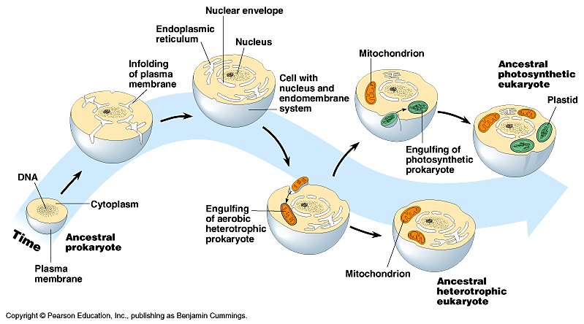
Animal Cell
Plant Cell

Evidence for the symbiotic theory comes from many sources. Both mitochondrial and chloroplast DNA is circular, and many copies of the DNA are present in each organelle, like prokaryotic cells. Both organelles have ribosomes and enzymes that are more similar to prokaryotes than eukaryotes. The fact that each organelle has its own plasma membrane (like that found surrounding other independent cells) is also evidence in support of the theory of endosymbiosis. Finally, both mitochondria and chloroplasts reproduce themselves independently of the cell in which they are found. In fact, many of the proteins that chloroplasts need to function are actually located in genomic (nuclear) DNA. Some of these similarities were first noted in the 1880s, but were largely ignored for almost a century!

Analysis Questions

- What kind(s) of eukaryotic cells have mitochondria?

- What kind(s) of eukaryotic cells have chloroplasts?

- List 3 sources of evidence for the endosymbiosis theory.

- What are three differences between prokaryotic and eukaryotic cells?

- On a separate page, write a creative paragraph describing the “thought” process of the first cells that describes how this symbiosis occurred. (Of course, there was no real thought involved, but imagine that you are a cell that encounters an interesting prokaryotic cell and tries to convince it to be ingested and help you out in some way).

