Independent Assortment Activity

In genetics, a Punnett square is used to show the chances that certain traits will appear in offspring. If only one trait is involved, a Punnett square with four boxes is used. If two traits are involved, then a sixteen box Punnett square is needed. A Punnett square always gives you the expected results. Offspring, however, are produced by chance and may not agree exactly with expected results.

In this investigation, you will:
- Substitute properly marked coins for gamete cells and toss the coins to represent offspring.
- Determine the expected offspring and compare it to observed offspring obtained through coin tossing.
- Write a report based on your data explaining the similarity or dissimilarity of expected and observed results and how sample size affects results.

MATERIALS
- 2 pennies, marked with A on one side and a on the other side
- 1 nickel, marked with m on one side and m on the other side
- 2 nickel, marked with M on one side and m on the other side

PROCEDURE

PART A: Cross Between Genotypes AaMm and Aamm

Expected Results
The Punnett square below represents a cross involving two characteristics, skin pigment and body height. The parents’ genotypes are AaMm and Aamm. The gene A is for normal skin pigment. The gene a is for albinism (no pigment). The gene M is for normal body height. The gene m is for short height (little person).
The Punnett square shows the possible gametes of each parent and the possible offspring. The squares are shaded according to phenotype.
AM Am aM am
Am  am  Am  am | AAMm | AAmm | AaMm | Aamm
 | AaMm | Aamm | aaMm | aamm
 | AAMm | AAmm | AaMm | Aamm
 | AaMm | Aamm | aaMm | aamm

- Determine the four phenotypes and how many offspring of each there are.
- Record these numbers in the “Number expected for 16 offspring” column of Table A. To calculate the next column, multiply each number just recorded by 6. Record these new numbers in the “Number expected for 96 offspring” column of Table A.

Observed Results
- Collect two pennies and two nickels labeled as shown below:
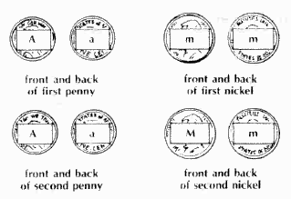
- Toss the four coins a total of 96 times.
- Read the genotypes that appear and record the phenotypes in Table A. (Use the Punnett square as a guide if necessary.) Make a tally in the proper row to indicate the phenotype represented by the coins.
- Place the totals for each phenotype in the proper column of Table A.

PART B: Cross Between Genotypes AaMm and AaMm

Expected Results
- Complete the blank Punnett square, allowing it to represent a cross between parents which are heterozygous for skin pigment and body height. As in Part A, the Punnett square will show the gametes and possible offspring.
- Determine the four phenotypes and how many offspring of each there are.
- Record these numbers in the “Number expected for 16 offspring” column of Table B. To calculate the next column, multiply each number just recorded by 6. Record these new numbers in the “Number expected for 96 offspring” column of Table B.

Observed Results
- Collect two pennies and two nickels labeled as shown below:
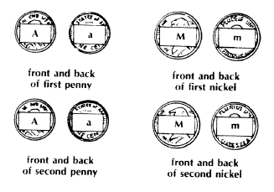
- Toss the four coins a total of 96 times.
- Read the genotypes that appear and record the phenotypes in Table B.
- Place the totals for each phenotype in the proper column of Table B.

Name: _______________________________________________ Date: _________________________ Block: ________

Table A: Results of Cross Between AaMm and Aamm

Phenotype Combinations | Genotypes | Number expected for 16 offspring | Number expected for 96 offspring | Toss Results | Total number observed
Normal skin and normal height | AAMm  AaMm
Normal skin and short height | AAmm  Aamm
Albino and normal height | aaMm
Albino and short height | aamm

Blank Punnett Square:

Table B: Results of Cross Between AaMm and AaMm

Phenotype Combinations | Genotypes | Number expected for 16 offspring | Number expected for 96 offspring | Toss Results | Total number observed
Normal skin and normal height | AAMM  AAMm  AaMM  AaMm
Normal skin and short height | AAmm  Aamm
Albino and normal height | aaMM  aaMm
Albino and short height | aamm

ANALYSIS
On a separate sheet of paper, summarize this activity by writing a report that includes the following:

- a) How the number of expected offspring in a genetic cross can be determined.
b) How the number of observed offspring in a genetic cross can be determined.

- a) How the number of expected offspring for Part A compares to the observed offspring for Part A. (Use specific data for your comparison.)
b) Why the numbers in these two columns may not be equal.

- How Part A supports our understanding of genetics. (Reread introduction if necessary.)

- Why the total of observed and expected offspring in Part A differ from the totals of observed and expected offspring in Part B.

- The need for using large numbers of observed offspring when attempting to prove that genetic totals of expected results do agree with observed results.

- How Part B supports our understanding of genetics.

- a) The advantage of tossing and reading properly marked coins over using living organisms.
b) Whether the comparison between coins and living organisms is correct and why.

